Medical Data History SQL Project

Prepared By
Mohan Baliji

Project Type
SQL-Based Healthcare Analytics Project

Project Overview
The Medical Data History SQL Project focuses on analyzing healthcare-related patient data using SQL queries and database operations. The project demonstrates SQL concepts such as filtering, aggregation, joins, grouping, conditional logic, and analytical querying techniques.
The dataset contains patient records, admissions, diagnoses, doctor information, allergies, province details, and healthcare-related information.

Dataset Description
The dataset contains:
- Patient demographics
- Patient admissions
- Diagnoses and medical conditions
- Doctor information
- Allergies data
- Province and location details
The dataset was analyzed using SQL to extract healthcare insights and demonstrate data analytics skills.

Project Objectives
- Analyze healthcare-related patient data using SQL
- Perform data exploration and reporting
- Apply SQL analytical functions
- Practice real-world healthcare data analysis
- Strengthen SQL skills for Data Analytics

Database Information
Database Name: project_medical_data_history
Tables Used:
- Patients
- Admissions
- Doctors
- Province_Names

SQL Concepts Demonstrated

Basic SQL
- SELECT
- WHERE
- ORDER BY
- DISTINCT
- LIMIT

Filtering
- LIKE
- BETWEEN
- IN
- NULL Handling

Aggregation
- COUNT()
- SUM()
- AVG()
- MAX()
- MIN()

Advanced SQL
- GROUP BY
- HAVING
- CASE
- UNION
- INNER JOIN
- Multi-table Joins

String Functions
- CONCAT()
- UPPER()
- LOWER()
- LENGTH()

Date Functions
- YEAR()
- DAY()

Key Analysis Performed

Patient Analysis
- Gender-based filtering
- Allergy analysis
- Weight analysis
- Height analysis
- Obesity classification
- Birth year analysis

Admission Analysis
- Same-day admissions
- Diagnosis-based analysis
- Multiple admission tracking

Doctor Analysis
- Patient-doctor relationship analysis
- Specialty-based analysis

Province Analysis
- Province-wise patient distribution
- City-level patient distribution

Screenshots

Database Schema
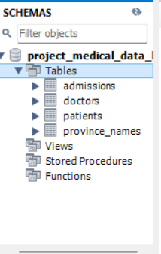

Query Execution
[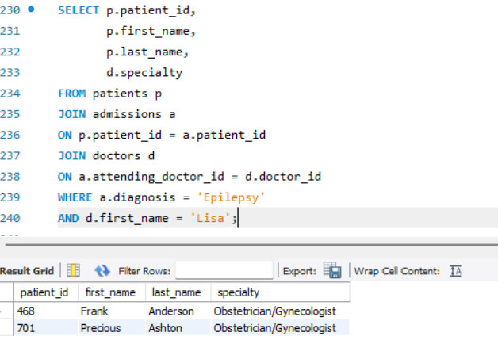

Query Results
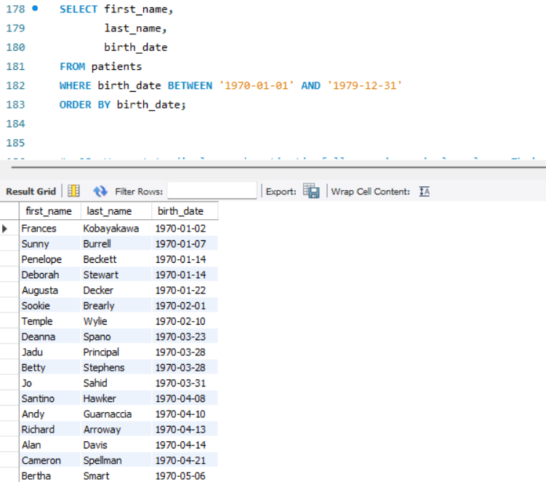

Join Query Results
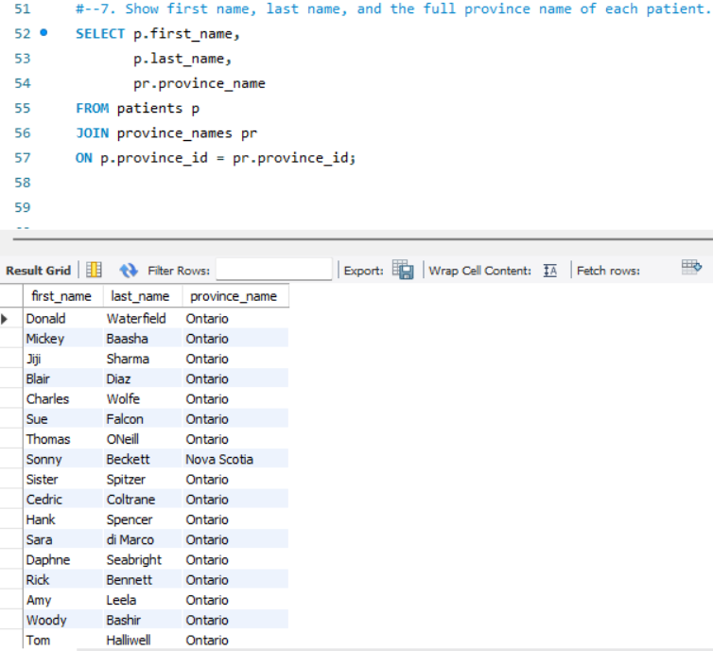

Aggregate Function Results
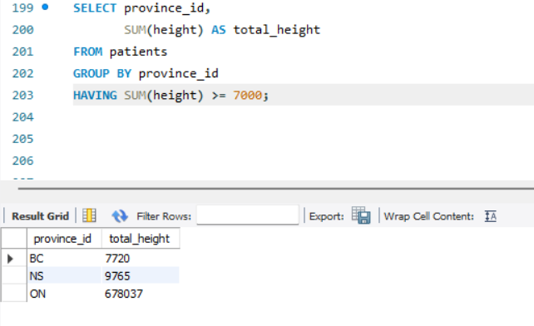

Business Insights
- Identified total male and female patients
- Analyzed allergy distribution
- Evaluated obesity levels using BMI calculations
- Identified repeated admissions
- Analyzed province-wise patient distribution
- Examined admission trends

Tools & Technologies
- SQL
- MySQL / PostgreSQL
- pgAdmin
- GitHub

Skills Demonstrated
- SQL Query Writing
- Data Analysis
- Database Management
- Data Cleaning
- Relational Databases
- Analytical Thinking
- Problem Solving

Conclusion
The Medical Data History SQL Project demonstrates practical SQL skills through healthcare data analysis. The project highlights the ability to write analytical SQL queries, perform data exploration, and generate meaningful insights from structured datasets. This project showcases skills relevant to Data Analyst and Business Analyst roles.

